Write **L** for the objects facing **LEFT** and **R** for the objects facing **RIGHT** in the boxes.

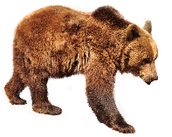

2.  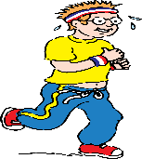

3. 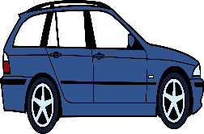 

Write **L** for the objects facing **LEFT** and R for the objects facing **RIGHT** in the boxes.

2.  

3.  

______ is a Duck

_______is an Apple

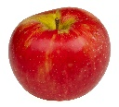

[This Photo](https://commons.wikimedia.org/wiki/File:Honeycrisp-Apple.jpg) by Unknown Author is licensed under [CC BY-SA](https://creativecommons.org/licenses/by-sa/3.0/)